u3a Festival - one month on

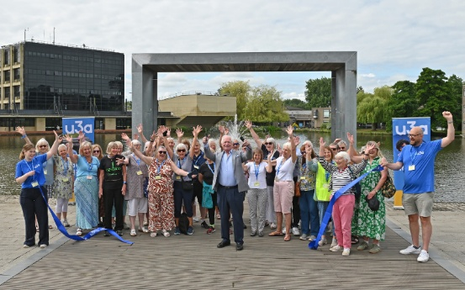

It's been a month since the u3a Festival at the University of York. Feedback from members has been overwhelmingly positive, with strong support for future Festivals.
Many respondents commented on the welcoming atmosphere, the enthusiasm of volunteers and the opportunity to meet people from other u3as, reinforcing the Festival's role in strengthening engagement with the wider movement.
Attendees praised the breadth and quality of activities on offer, valuing the opportunity to explore new interests, develop existing ones and take part in experiences that were not always available through their local u3a.
There were some areas flagged for improvement that will be taken into consideration when planning future events.
Watch our Festival highlights film.

Other News



Journeys worth sharing – u3a getaways
This exciting new initiative has been developed especially for u3a members, combining expert-led cultural learning, carefully selected destinations and the opportunity to share new experiences with like-minded people from across the u3a movement.
This Autumn members have the chance to join Appreciating Shakespeare in Stratford-upon-Avon from 12 to 15 October 2026 – an opportunity to explore the Bard's life and works in his home town. Learn more about the Shakespeare tour and explore the full schedule of future getaways.

